Michigan Department of Agriculture and Rural Development

Special Transitory Food Unit and Mobile Food Establishment
Plan Review Manual

Food & Dairy Division
Michigan Department of Agriculture
and Rural Development
P.O. Box 30017
Lansing, MI 48909
(800) 292-3939

Table of Contents

Page#
Introduction | Submitting Plans, Differences between Special Transitory Food Unit and Mobile Food Establishment | 3
Suggested Changes | Form | 6
Plan Submittal | Documents Required | 7
Plan Review Process | Process Chart | 9
Definitions | Definitions (Defined words are italicized in the text) | 10
Part 1 | Menu, Food, & Food Processes | 12
Part 2 | Employee Health & Hygiene | 16
Part 3 | Food Contact Surfaces | 19
Part 4 | Water Supply | 23
Part 5 | Sewage Disposal | 29
Part 6 | Environmental Hazards | 31
Part 7 | Floors/Walls/Ceilings | 32
Part 8 | Equipment Specifications | 34
Part 9 | Electricity | 37
Part 10 | Mechanical Ventilation | 39
Part 11 | Additional Circumstances | 42
Part 12 | Diagram | 42
Acknowledgements |  | 44

Introduction

This manual is designed to assist in achieving greater uniformity in the plan review process by providing technical assistance for design of special transitory food units (STFUs) and mobile food establishments. The purpose of plan review is to ensure the proposed construction and operation of a STFU or mobile food establishment is compliant with the Michigan Food Law (FL) of 2000, as amended and the Michigan Modified 2009 Food Code (FC) before the STFU or mobile food establishment is constructed. This manual is intended to be used in conjunction with the “Special Transitory Food Unit-Mobile Plan Review and SOP Worksheet”. Worksheet section references are indicated throughout this manual. Individuals who have questions during the plan review process should call the Local Health Department (LHD) who will be conducting the plan review. Agency contact information is available at:
https://www.michigan.gov/mdhhs/0,5885,7-339--96747--,00.html

Plan review of Mobile Food Establishments and STFUs is a necessary requirement for Michigan's local health departments.

Who Must Submit Plans?

When plans are required, these plans must be approved prior to construction or remodeling! Please submit your STFU or mobile food establishment plan review package to the appropriate regulatory authority. It is ideal to have the STFU/mobile food establishment reviewed and licensed by the Local Health Department in the county in which you live or the county where you intend to operate most of the time. The regulatory agency will review the plans and specifications as soon as practical to determine their completeness and adequacy. The regulatory agency has up to 30 business days to review and approve complete plans and specifications. Submission of incomplete plans and specifications will delay the plan review process and the construction of your STFU/mobile food establishment. If a submission of complete plans and specifications is not reviewed within 30 business days of receipt by the regulatory agency, the plans and specifications will be considered complete and adequate for construction. However, the regulatory agency still has the authority to require changes to the built STFU/mobile food establishment. Plan review fees vary, and you will need to contact the responsible regulatory authority for appropriate fees.

The following STFUs and mobile food establishments are required to submit plans for review and approval:

  - Newly constructed, altered, extensively remodeled, or converted units.
  - STFU and mobile food establishments that were licensed by another state.
  - Formerly Michigan licensed STFU or mobile food establishment, that previously had gone through the plan review process and were approved, may need to go through the plan review process again when trying to obtain a new license or a license from a differing regulatory authority. The requirement to go through the plan review process for formerly licensed STFUs or mobile food establishments will be at the discretion of the regulatory authority who is issuing the new license.
  - A change in operation or license type such as going from a mobile food establishment to an STFU; or from a temporary food establishment to either a mobile food establishment or STFU may need to go through the plan review process. The requirement to go through the plan review process will be at the discretion of the regulatory authority who is issuing the license.

Once the plans have been approved and construction completed according to the approved plans, an application for a food establishment license must also be submitted to the appropriate regulatory agency at least thirty days before the STFU/mobile food establishment plans to operate. An inspection must then be conducted by the regulating agency before a license can be issued.

Differences Between STFU and Mobile Food Establishment
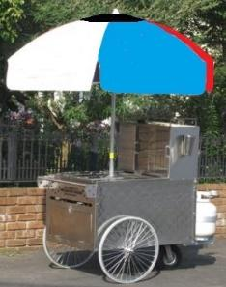
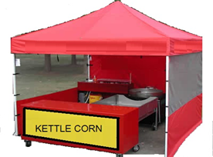
Both STFUs and mobile food establishments are permanently licensed food operations that are intended to be transportable from one location to another. STFUs and mobile food establishments can occur in various physical forms including but not limited to fully enclosed trailer, pushcart, vehicle, watercraft, tent, or other design that is movable. Your licensing as either a STFU or mobile food establishment of the unit will depend upon your menu, intended food operations, and physical construction of the unit.

An STFU is a transitory food establishment that is licensed to operate throughout the state for any number of days. The unit is equipped and operates in a manner so as not to be required to return to a base of operations for resupply or cleaning. STFUs can be of varied designs.

An STFU license holder shall do all the following (FL 6137):
- Keep a copy of the approved standard operating procedures (SOPs) in the unit and available for review.
- Operate in compliance with SOPs approved by the regulating authority.
- Before serving food within the jurisdiction of a Local Health Department (LHD), notify the LHD in writing of each location in the jurisdiction at which food will be served and the dates and hours of service. This notice must be delivered not less than 4 business days before any food is served or prepared within the jurisdiction of the LHD. A copy of an “Intent to Operate” notice is available at:
https://www.michigan.gov/documents/MDA_FSSS_STFUForm_65341_7.pdf
- While in operation, request and receive 2 evaluations (operational inspections) per licensing year (May 1st to April 30th). These requested evaluations should be spaced generally over the span of the operating season. A LHD or MDARD shall charge a fee of $90.00 for such an evaluation. A regulatory authority retains the right to inspect an STFU regardless if an evaluation was requested by the license holder or not. A request for an evaluation can be indicated on the “Intent to Operate” notice.
- Send a copy of all paid evaluation reports to the regulatory authority that issued the license within 30 days after receipt.

If a license holder fails to comply with any of these listed requirements or the Michigan Modified Food Code, the STFU may be ineligible for licensure as an STFU for the following licensing
year and must apply for temporary or other type of food establishment licenses.

A mobile food establishment may be similar in structure to an STFU but is required to return to a mobile food establishment commissary once every 24 hours. The mobile food establishment commissary is required to be a separately licensed food establishment in addition to the licensed mobile food establishment. A mobile food establishment license is better suited for food operations where the transportable unit is not equipped to handle all food preparation, storage, warewashing, etc. A mobile food establishment would be inspected by the licensing regulatory authority at a frequency based upon the complexity of the operation. These inspections would not need to be requested by the mobile food establishment operator. If the mobile food establishment operates on a regular scheduled route, the regulatory authority may request a copy of this route at time of licensure and whenever the scheduled route changes.

When the mobile food establishment commissary will be licensed under a different operator than the operator of the licensed mobile food establishment, then the license holder of the mobile food establishment will need to complete a “Mobile Food Establishment Commissary Verification Form” and provide a copy to the appropriate regulatory authorities. This form verifies that the mobile food establishment commissary intended to be used by the mobile food establishment can support the services and maintenance requirements of the mobile food establishment. A new “Mobile Food Establishment Commissary Verification Form” form shall be completed and submitted to the appropriate regulatory authorities whenever a change in the mobile food establishment commissary location occurs. Copy of the “Mobile Food Establishment Commissary Form” can be found at:
https://www.michigan.gov/mdard/0,4610,7-125-50772_50775_51203---,00.html

A mobile food establishment license holder shall do the following (FL 6135):
- Affix the name and address of the business operating a mobile food establishment to each side of the exterior of the mobile food establishment in letters not less than 3 inches high and 3/8 of an inch wide and shall contrast with the background color of the mobile food establishment. When more than 1 mobile food service establishment is operated by the same person, the regulatory authority shall assign a number to each mobile food establishment.
- A copy of any limitations attached to the license of a mobile food service establishment shall be carried on the mobile food service establishment at all times.
- If a mobile food establishment is operating on a regularly scheduled route, the regulating authority may require the license holder to provide a copy of the route schedule when the license is approved and every time the route schedule is changed.
- The regulatory authority or the operator, in the presence of the regulatory authority, shall affix 2 decals provided by the regulatory authority on the mobile food establishment at the time the license is issued. The decals shall be conspicuously displayed on each side of the mobile food establishment to be visible when in transit and while serving the public.

The Food Law (FL) and the Michigan Modified FDA 2009 Food Code (FC), which is adopted by reference and is a part of the Food Law, is used as a reference in completing this guide. To view the Food Law and Food Code and other fact sheets go to:
http://www.michigan.gov/mdard/0,4610,7-125-50772_45851_61711---,00.html
You can call 800-292-3939 to request free single copies.
Suggestion Sheet
Mobile/STFU Plan Review Manual

Suggestions for changes to this plan review manual are welcomed from all users (e.g., food service operators, architects, engineers and regulators, etc.). Revisions to documents are made periodically as needed. Thank you for taking the time to submit your ideas.

Name: __________________________________ Phone: ___________________

Fax: ________________ E-mail: _______________________________________

Address: __________________________________________________________

City, State, Zip: _____________________________________________________

Submit suggested changes to:  Plan Review Specialist  Food Service Program  Food & Dairy Division  Michigan Department of Agriculture and Rural Development  PO Box 30017  Lansing, MI. 48909 | E-mail: Garvina1@michigan.gov

For suggested changes, please list section specific location in document. You may list your suggestions below or attach separate sheets. Please be specific and clear.

____________________________________________________________________________________

____________________________________________________________________________________

____________________________________________________________________________________

____________________________________________________________________________________

____________________________________________________________________________________

____________________________________________________________________________________

____________________________________________________________________________________

____________________________________________________________________________________

____________________________________________________________________________________

____________________________________________________________________________________

____________________________________________________________________________________

____________________________________________________________________________________

Plan Review Submittal Instructions

Congratulations! You are proposing to build a STFU/mobile food establishment in Michigan. The regulatory agency responsible for conducting the plan review is dependent upon the food operations of the STFU/mobile food establishment.
- The majority of STFU/mobile food establishments are licensed and regulated by LHDs while some are regulated by MDARD. It is recommended to first contact the LHD in the county in which you live or the county where you intend to operate most of the time to discuss which agency would be responsible for conducting the plan review

All the following items should be completed and compiled into a single package or the plan review may be delayed as additional material is requested by the regulatory authority. Documents listed below in italics can be found at https://www.michigan.gov/mdard/0,4610,7-125-50772_50775_51203---,00.html or contact the LHD for copies.

- Completed STFU/Mobile Plan Review Application and applicable plan review fees
- STFU/mobile food establishment plan review that is conducted by LHD is mandatory. LHD plan review fees vary by jurisdiction. Contact the LHD who will be conducting the plan review for applicable fees.
- If the STFU/mobile food establishment plan review is to be conducted by MDARD, contact MDARD for applicable fees at 1-800-292-3939.

- Completed STFU/Mobile Plan Review Worksheet and Standard Operating Procedures
- The STFU/Mobile Food Establishment Plan Review Worksheet and Standard Operating Procedures document is used to provide construction details for the STFU/mobile food establishment as well as the standard operating procedures (SOPs) for the unit.

- Complete Menu
- Submit an intended menu that includes all food and drink being offered by the STFU/mobile food establishment.

- Certified Manager Documentation
- Most food establishments are required to employ at least one (1) full time certified manager employee who is certified under the American National Standards Institute (ANSI) accredited certification program (Food Law 2000, as amended, §289.2129). Documentation verifying this requirement needs to be provided prior to opening.

- One Complete Set of Scaled Plans (1/4” per foot is a normal, easy to read scale) that show:
- Proposed equipment layout plan with all items accurately identified.
- Mechanical plan (e.g. cooking ventilation systems: including hood, duct and exhaust fans).
- Plumbing plan (e.g. handsinks, food preparation sink, warewashing sinks, dishmachines, water heater, hot and cold water lines, sewer drains, floor drains/sinks, fresh water and waste water holding tanks for traveling units).
- Lighting plan, indicating light fixtures and type of shielding where applicable.

- Equipment Specifications
- Include manufacturer’s specifications “cut” sheet for each piece of equipment. Minimum information needed includes the following:
  - Type, manufacturer, model number, performance capacity, dimensions.
  - How equipment will be installed (e.g. on legs or wheels, fixed or flexible utility connections)
  - Indicate if equipment is new or used and if it is certified or classified for sanitation by an American National Standards Institute (ANSI)-accredited certification program (e.g. NSF, ETL, UL, etc.).
  - Sanitation Standard Operating Procedures (SSOPs): Include any available cleaning and maintenance instructions for food processing, cutting, grinding equipment.

FOOD ESTABLISHMENT PLAN REVIEW PROCESS

*Regulatory agency has authority to issue a stop work order when construction begins before plans are approved.

Definition
Defined words are in italics in the text of the document

Acceptable Food Equipment means food equipment that is deemed to be in conformance with Food Code provisions such as equipment that is certified or classified for sanitation by an American National Standards Institute (ANSI)-accredited certification program. Such equipment is deemed to comply with Parts 4-1 and 4-2 of the Food Code.

The term “certified” is used when an item of food equipment has been evaluated against an organization’s own standard. The term “classified” is used when one organization evaluates an item of food equipment against a standard developed by another organization.

Approved means acceptable to the regulatory authority based on a determination of conformity with principles, practices, and generally recognized standards that protect public health.

Easily Cleanable means:
- A characteristic of a surface that:
  - Allows effective removal of soil by normal cleaning methods;
  - Is dependent on the material, design, construction, and installation of the surface; and
  - Varies with the likelihood of the surface's role in introducing pathogenic or toxigenic agents or other contaminants into food based on the surface's approved placement, purpose, and use.
- "Easily cleanable" includes a tiered application of the criteria that qualify the surface as easily cleanable as specified in item 1 of this definition to different situations in which varying degrees of cleanability are required such as:
  - The appropriateness of stainless steel for a food preparation surface as opposed to the lack of need for stainless steel to be used for floors or for tables used for consumer dining; or
  - The need for a different degree of cleanability for a utilitarian attachment or accessory in the kitchen as opposed to a decorative attachment or accessory in the consumer dining area.

Food Establishment means an operation where food is processed, packed, canned, preserved, frozen, fabricated, stored, prepared, served, sold or offered for sale. Food establishment includes, but is not limited to, a food processor, a food warehouse, a food service establishment, and a retail grocery. Food establishment does not include any of the following:
- A charitable, religious, fraternal or other non-profit organization operating a home-prepared baked goods sale or serving only home-prepared food in connection with its meetings or as part of a fund-raising event.
- An inpatient food operation located in a health facility or agency subject to licensure under article 17 the public health code, MCL 333.20101 to 333.22260.
- A food operation located in a prison, jail, state mental institute, boarding house, fraternity or sorority house, convent or other facility where the facility is the primary residence for the occupants and the food operation is limited to serving meals to the occupants as part of their living arrangement.

Food Service Establishment means a fixed or mobile restaurant, coffee shop, cafeteria, short order cafe, luncheonette, grill, tearoom, sandwich shop, soda fountain, tavern, bar, cocktail lounge, nightclub, drive-in, industrial feeding establishment, private organization serving the public, rental hall, catering kitchen, delicatessen, theater, commissary, or similar place in which food or drink is prepared for direct consumption through service on the premises or elsewhere, and any other eating or drinking establishment or operation where food is served or provided to the public. Food service establishment does not include any of the following:
- A motel that serves continental breakfasts only.
- A bed and breakfast that has 10 or fewer sleeping rooms for rent.
- A bed and breakfast that has more than 10 sleeping rooms for rent, if the bed and breakfast serves continental breakfasts only.
- A child care organization regulated under 1973 PA 116, MCL 722.111 to 722.128, unless the establishment is carrying out an operation considered by the director to be a food service establishment.

Mobile Food Establishment means a food establishment operating from a vehicle, including a watercraft, that returns to a mobile food establishment commissary for servicing and maintenance at least once every 24 hours.

Mobile Food Establishment Commissary means an operation that is capable of servicing a mobile food establishment.

Ready-to-Eat Food means foods that are edible without washing, cooking or additional preparation. This includes, but is not limited to, raw animal foods that have been cooked; raw fruit and vegetables that have been washed, have had rinds, peels, husks or shells removed, and/or have been cooked for hot holding; all time/temperature control for safety foods that have been cooked and cooled; and baked goods. For further clarification of definition see Michigan Modified Food Code

Special Transitory Food Unit (STFU) means a temporary food establishment that is licensed to operate throughout the state without the 14-day limits or a mobile food establishment that is not required to return to a commissary

Temporary Food Establishment means a food establishment which operates at a fixed location for a temporary period not to exceed 14 consecutive days.

Time/Temperature Control for Safety Food-TCS (formerly called Potentially Hazardous Food) means a food that requires time/temperature control for safety (TCS) to limit pathogenic microorganism growth or toxin formation. For complete definition, see Michigan Modified Food Code
- TCS food includes:
  - An animal food that is raw or heat-treated; a plant food that is heat-treated or consists of raw seed sprouts, cut melons, cut leafy greens, cut tomatoes or mixtures of cut tomatoes that are not modified in a way so that they are unable to support pathogenic growth or toxin formation or garlic-in-oil mixtures that are not modified in a way that results in mixtures that do not support pathogenic microorganism growth or toxin formation; and
  - Except as specified in Subparagraph (2)(d) of this definition, a food that because of the interaction of its A_{W} and pH values is designated as Product Assessment Required (PA) in Table A or B of the Michigan Modified Food Code.

Warewashing means the cleaning and sanitizing of utensils and food-contact surface of equipment.

Part 1
Menu, Food, & Food Processes
The menu for an STFU/mobile food establishment is an integral part of the plan review process. The menu or a listing of all the food and beverage items to be offered at the STFU/mobile food establishment must be submitted to the regulatory authority as part of the plan review packet. The menu dictates needed space and equipment requirements for the safe preparation and service of the proposed foods in order to prevent foodborne illness.
When reviewing the menu, it is important to identify those food processes that are complex in nature which may create a greater risk of contamination and foodborne illness. The STFU/mobile food establishment should be designed to support the intended food processes and reduce the risk of contamination. Complex food processes can include but are not limited to:
- Multiple ingredients being assembled or mixed
- Time/Temperature Control for Safety Foods (TCS)
- Foods which will be prepared or held for several hours prior to service
- Foods requiring cooling and reheating
- Multiple step processing (passing through the temperature danger zone, 135˚F - 41˚F more than once)

The source and quantity of food to be served should be reviewed along with the preparation and post-preparation operations. It is imperative to have knowledge of this information so that a proper assessment of the construction of the STFU/mobile food establishment can be made to determine if the proposed construction and equipment will support the proposed menu.
STFUs/mobile food establishments must be built with proper equipment and space (e.g. cold/hot holding equipment, food preparation surfaces, warewashing, handwashing station(s), dry storage etc.) to support the intended food processes for that STFU/mobile food establishment. Equipment location and spacing is also important to prevent contamination of food and aid in cleanability of the STFU/mobile food establishment. Typically, the more complex the food processes are that occur within the STFU/mobile food establishment, the greater the physical construction, equipment, and spacing needs.

STFU and Mobile Food Establishment Worksheet Help
Worksheet Question # 1 |  | Food Code  & Food Law* | Guidance
Item A | Menu | FC 8-201.12 | - List all foods, including beverages, that will be served from the STFU/mobile food establishment. This list must be submitted to determine the processes and type of operation the unit must accommodate.
Item  B | Food Source | FC 3-2 | - List sources for all foods. Foods must come from sources that comply with Law. Home prepared foods or cottage foods are not permitted sources.
Item C | Storage | FC 3-501.16, 3-305.11, 3-305.12, 3-307.11, 4-301.11, 6-202.111 | - List how foods items will be stored during operation of the STFU/mobile food establishment.  - TCS foods must be stored in refrigerated or hot holding units of sufficient capacity to ensure these foods will remain in compliant temperatures.  - Foods must be stored in a fashion to prevent contamination.  - Adequate shelving, tables, and/or containers should be provided to prevent food from being stored on the floor/ground. Location of storage space/equipment needs to be indicated on the layout plans of the unit.  - During periods of non-operation, food cannot be stored in a private home or any other unlicensed facility. STFUs must store food on the unit or at a licensed food establishment. Mobile food establishments must store food either on the unit or at the licensed mobile food establishment commissary.
Item D | Food Transportation | FC 3-501.16, 3-305.11, 3-305.12, 3-307.11 | - Describe how foods will be held at proper temperatures and/or protected from contamination while being transported. This includes food transported from the food supplier or commissary to the STFU/mobile food establishment as well as how the food is transported within the STFU/mobile food establishment while the unit is traveling to the food event site.  - When TCS foods are transported, they must be maintained at proper cold or hot holding temperatures. Coolers, Cambro containers, or other insulating equipment must be utilized when the food is in transit to ensure compliant food temperatures.  - Non-TCS foods, such as dry goods, must be protected to prevent contamination during transportation. Items such as cabinets or containers are potential items to store and protect non-TCS foods.
Item E | Thawing | FC 3-501.13 | - Identify all frozen TCS foods that must be thawed before usage and mark which thawing method will be used for each food item.  - Frozen TCS foods are not permitted to thaw at room temperature (e.g. setting on the counter to thaw).
Item F | Bare Hand Contact | FC 3-301.11 | - Bare hand contact with ready-to-eat foods is not permitted.  - Mark the methods (barriers) used by this operation to prevent bare hand contact with ready-to-eat foods (e.g. use of gloves, utensils, deli tissue, or other effective means).
Item G | Cross Contamination Prevention | FC 3-302.11, 304.12, 4-602.11 | - Foods must be prepared and stored in a fashion to avoid cross contamination. Methods for avoiding cross contamination include, but are not limited to:  - Storing ready-to-eat foods, cooked foods, and produce away from raw animal items.  - Separating raw beef, fish, lamb, pork, and poultry from each other unless intentionally mixing during preparation.  - Storing raw, unwashed produce away from washed produce and other ready-to-eat foods.  - Using separate utensils (e.g. spatulas, tongs, knives, etc.) and preparation surfaces (e.g. cutting boards) for preparing raw foods and ready-to-eat foods.  - Appropriately storing in-use utensils and cleaning them at required frequency.  - List how foods (ready-to-eat, raw animal items, washed produce, unwashed produce) will be protected from cross-contamination during storage and preparation. Consider what equipment and preparation surfaces will be needed to avoid cross-contamination. Inadequate space and/or equipment may limit the types of food items (e.g. raw animal foods, unwashed produce) that can be utilized within the STFU/mobile food establishment.
Item H | Cooking | FC 3-401.11, 3-603.11, 4-301.11, FL 6149 | - Various foods, especially raw animal foods, need to be cooked to a specific temperature to make them safe for consumption. Following are the minimum cooking temperatures for the listed food items.  Cooking Temperature Food Items  165°F Poultry; baluts; stuffed fish, meat, pasta, poultry, or ratites; stuffing containing fish, meat, poultry, or ratites; and raw animal foods cooked in a microwave.  155°F Ratites; mechanically tenderized or injected meats; comminuted fish, meat or commercially raised game animals; and raw eggs except those that are broken and prepared in response to a consumer’s order for immediate service (see below).  145°F Raw eggs that are broken and prepared in response to a consumer’s order and that will be served immediately; fish; and meat (including commercially raised game animals)  135°F Fruits and vegetables that are cooked for hot holding.  Time and temperature as specified under FC 3-401.11(B) Whole meat roasts including beef, corned beef, lamb, pork, and cured pork roasts.  *Except for whole meat roasts, the listed foods should be maintained at these listed temperatures for at least 15 seconds.  - If raw or undercooked animal foods (e.g. hamburgers, eggs) are to be served, then a consumer advisory must be provided. Contact your regulatory authority for help in developing your consumer advisory.  - On the worksheet, list the foods that will be cooked, the equipment (e.g. grill, fryer, stove, etc.) used to cook that food item and the internal cooking temperature for that food item. The location of the cooking equipment must be indicated on the layout plans of the unit. Include how you intend to monitor the food to ensure it reaches proper cooking temperatures.
Item I | Cooling | FC 3-501.14, 3-501.15, 4-301.11 | - Cooked TCS foods shall be cooled within 2 hours from 135°F to 70°F; and within a total of 6 hours from 135°F to 41°F or less.  - TCS food prepared from ingredients at ambient temperature (e.g. potato salad) shall be cooled within 4 hours to 41°F or less.  - To cool foods within these time frames, rapid cooling methods must be utilized. These methods include but are not limited to:  - Placing food in shallow pans;  - Covering food loosely or leaving it uncovered to help cool faster when place in cold holding equipment;  - Separating food into smaller or thinner portions;  - Using rapid cooling equipment (e.g. ice paddle, blast chiller);  - Stirring the food in a container placed in an ice water bath;  - Adding ice as an ingredient;  - Using containers that facilitate heat transfer (e.g. metal containers instead of plastic; or  - Other effective methods.  - Due to the limited space and equipment available on STFUs/mobile food establishments, cooling of foods may not be possible. Consult your regulatory authority if you plan to cool foods on your STFU/mobile food establishment.  - List on the worksheet what foods you intend to cool, the cooling method you will use, and the time frames in which you will cool the food. Include how you will monitor the food to determine if is cooling within required times and temperatures.
Item J | Reheating for Hot Holding | FC 3-403.11, 4-301.11 | - TCS foods that are cooked, cooled, and reheated for hot holding must be reheated so that all parts of the food reach a temperature of at least 165°F for 15 seconds.  - TCS foods that are reheated in a microwave for hot holding must be reheated to a temperature of at least 165°F and the food must be rotated or stirred, covered, and allowed to stand covered for 2 minutes after reheating.  - Ready-to-eat food taken from a commercially processed, hermetically sealed container, or from an intact package from a food processing plant must be heated to a temperature of at least 135°F for hot holding. This temperature requirement also applies if a microwave is used to reheat this commercially processed food from intact package.  - All reheating for hot holding must be done rapidly and not exceed 2 hours.  - On the worksheet, list all foods intended to be reheated for hot holding; if reheated portions will be individual servings or bulk; equipment (e.g. grill, oven, microwave, etc.) used to reheat; the temperature food will be reheated to and the time it will take to reheat. The location of reheating equipment must be indicated on the layout plans of the unit. Include how you intend to monitor the food to determine if it is reheated to proper temperature within needed time frames.
Item K | Hot Holding | FC 3-501.16, 4-301.11 | - TCS food held hot during service must be held at a minimum temperature of 135°F after reaching proper internal cooking or reheating temperatures.  - On the worksheet, list foods that will be held hot and the type of equipment (e.g. steam table, soup wells, etc.) that will be used for this purpose. The location of hot holding equipment must be indicated on the layout plans of the unit. Include how you intend to monitor the hot held food to ensure it is at the required hot holding temperature.
Item L | Cold Holding | FC 3-501.16, 4-301.11 | - TCS food held cold must be held at a temperature of 41°F or less.  - On the worksheet, list foods that will be held cold and the type of equipment (mechanical refrigeration, coolers with ice, etc.) that that will be used for this purpose. Enough cold holding space must be provided to support your intended operations. The location of cold holding equipment must be indicated on the layout plans of the unit. Include how you intend to monitor the cold held food to ensure it is at the required cold holding temperature.  - If coolers with ice are planned to be used for cold holding TCS foods, consult your regulatory authority. This method of cold holding may not be adequate depending on your proposed operations.
Item M | Time Alone as a Control | FC 3-501.19 | - Under specific and limited circumstances, time instead of temperature may be used to control bacterial growth in food that is TCS (e.g. leaving TCS food out at room temperature). A careful reading of the relevant Food Code section 3-501.19 and discussion with the regulating authority is recommended before making a proposal of using time as a control. You must prepare a standard operating procedure in advance for each food item where time as a control is proposed, develop a tracking/monitoring system for how long the food is out of temperature, and list actions to take when the food reaches its time and/or temperature limit.  - On the worksheet:  - List the TCS foods intended to be held out of temperature control.  - Describe how long the listed TCS foods will be held out of temperature control and how this food will be marked to track time.  - Describe what action will be taken with the time limit has been reached.
Item N | Date Marking | FC 3-501.17, 3-501.18 | - Date marking of certain foods is required to prevent foodborne illness from Listeria monocytogenes. Foods required to be date marked are:  - TCS;  - Ready-to-eat; and  - Held under refrigeration for more than 24 hours before sale or service.  - These foods are to be date marked at the time of preparation, or if received commercially prepared, when the package is opened. The pre-printed manufacturer’s date on commercially prepared products is not a date mark.  - The date mark (e.g. calendar dates, days of the week, color coded marks, etc.) shall indicate a time period not to exceed 7 days from day of preparation or opening of commercial packaging. The day of preparation or opening of the commercial packaging is considered day 1.  - Some ready-to-eat TCS food are exempt from dating marking. These food items are listed under Food Code section 3-501.17(F).  - On the worksheet, list the foods or groups of foods (e.g. deli meats) that will require a date mark and describe the date marking method to be used along with the maximum number of days between preparation/opening and discarding.
*FC =Michigan Modified Food Code. *FL = Food Law
To view the food code, food law and other fact sheets go to: http://www.michigan.gov/mdard/0,4610,7-125-50772_45851_61711---,00.html or call 800-292-3939 to request single free copies.

PART 2
EMPLOYEE HEALTH AND HYGIENE

Employee health and hygiene are important factors in preventing foodborne illness. Employees must follow proper health and hygiene practices to prevent contamination of food. Employee health and hygiene encompasses: hygienic practices, handwashing, and health reporting.

Hygiene Practices
- Ensure employees are following proper hygienic practices which include but are not limited to:
  - Working in clean outer clothing
  - Wearing proper hair restraint
  - Not using tobacco products in food areas
  - Not eating in food areas
  - Drink only from closed beverage containers in food areas
  - Covering cuts/wounds:
    - On hands or wrists with an impermeable cover, such as a finger cot, and a single use glove is worn over the impermeable cover,
    - On exposed portions of the arms with an impermeable cover, and
    - On other parts of the body with a dry, durable, tight-fitting bandage.
  - Not wearing nail polish unless covered by a single use glove and nails kept trimmed and clean
  - Not wear hand/wrist jewelry, except for a plain ring such as a wedding band
  - Not working with exposed food, clean equipment, utensils, and linens and exposed single service items if the employee is experiencing persistent sneezing, coughing or a runny nose
- Employees need to be made aware of their responsibility to follow proper hygienic practices and comply with the requirements in the Food Code.

Handwashing
- Proper handwashing reduces the number of pathogens that can be transmitted to food. To achieve proper handwashing, the following must be addressed:
  - Method for washing hands
    - Employees shall clean their hands and exposed portions of their arms for at least 20 seconds, at a designated handwashing sink that is equipped with soap and hand drying provisions
    - Washing hands shall occur in the following order:
      - Rinse under clean, running warm water;
      - Apply cleaning compound (soap);
      - Rub together vigorously for at least 10 to 15 seconds paying attention to
removing soil from underneath the fingernails;
      - Thoroughly rinse under clean, running warm water; and
      - Immediately follow the cleaning procedure with thorough drying using an
approved hand drying method (e.g. single use paper towels).
  - When to wash hands
    - Employees shall clean their hands and exposed portions of
their arms immediately before starting food preparation (including working with
exposed food, clean equipment and utensils, and unwrapped single service articles)
and:
      - After touching bare human body parts other than clean hands and clean, exposed portions of arms;
      - After using the toilet room;
      - After caring for or handling service animals or aquatic animals;
      - After coughing, sneezing, using a handkerchief or disposable tissue, using tobacco, eating, or drinking;
      - After handling soiled equipment or utensils;
      - During food preparation, as often as necessary to remove soil and contamination and to prevent cross contamination when changing tasks;
      - When switching between working with raw food and working with ready-to-eat food;
      - Before donning gloves for working with food; and
      - After engaging in other activities that contaminate the hands.
  - Availability of handwashing stations
    - At least one handwashing station must be conveniently located as part of the STFU/mobile food establishment. Additional handwashing stations may be required dependent upon the size and complexity of the establishment.
    - Handwashing stations shall be easily accessible and may not be used for purposes other than handwashing. Sinks used for food preparation, washing equipment or utensils, or service (mop sinks) shall not be used for handwashing.
    - Each handwashing station shall be able to provide water at a temperature of at least 100˚F. You will need to indicate within your submitted plans on how you plan to provide this hot water for the handwash station, even if a temporary or portable handwashing station is proposed.

Barrier between handwash station and warewashing area.
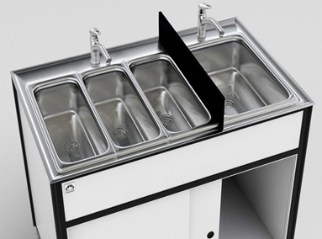
    - Splash from use of a handwashing station may not contaminate food, food-contact surfaces, clean equipment or utensils. A washable baffle or barrier may be needed if the handwashing sink is located next to a food preparation area, utensil or equipment storage, or food-contact surface and if the space between the handwashing sink and food, food preparation, food-contact surfaces, and clean utensils and equipment does not provide adequate protection.
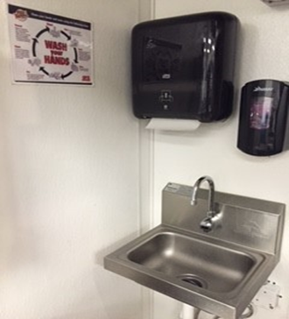
    - Handwashing stations must be supplied with hand soap, approved hand drying methods (e.g. paper towels), and a visible sign or poster that notifies employees to wash their hands.
Hand wash
sign

Hand drying method
Hand soap

    - Handwashing stations shall be constructed to be easily cleanable and the overall design/set up of the handwash station may vary depending on the operation of the STFU/mobile food establishment. Each handwashing station must be provided with water that meets drinking water criteria. Wastewater from handwashing must be adequately collected and properly disposed. Consult with the regulatory authority regarding the most appropriate type of handwashing stations for your STFU/mobile food establishment.
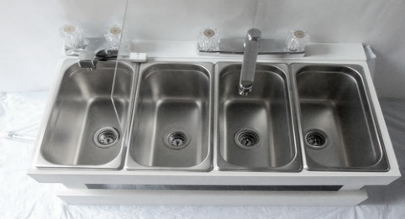
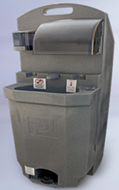
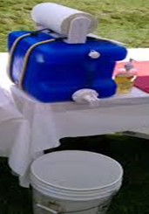
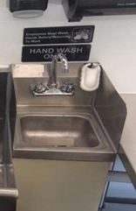

Temporary handwash
station
Fixed standalone handwash
station
Portable handwash
station
Fixed handwash as part
of 3-comparmtent

Employee Health
- Employees are required to report information about their health and activities as they relate to
diseases that are transmissible through food. Employees must be made aware of and report
specific symptoms and illnesses as outlined within the Food Code.
- Depending upon the reported symptom/illness, appropriate action must be taken regarding restricting or excluding that employee from food activities as required by the Food Code. Notifying the regulatory authority may also be required.
- Employees with reportable symptoms/illnesses shall not return to food activities until they meet the return requirements as outlined in the Food Code.
- For more information regarding what symptoms and illnesses are reportable, actions to take, and when an employee can return to food activities contact your regulatory authority and review Food Code sections 2-201.11, 2-201.12, and 2-201.13.
- An education poster outlining employee health requirements can be found at:
https://www.michigan.gov/documents/mda/MDA_FdEmplFBIGuidePoster_255329_7.pdf

STFU and Mobile Food Establishment Worksheet Help
Worksheet  Question #2 |  | Food Code &  Food Law | Guidance
Item A | Hygiene Practices | FC 2-201.11(e), 2-302.11, 2-303.11, 2-304.11, 2-401.11, 2-401.12, 2-402.11 | - On the worksheet, initial each line indicating that employees shall follow proper hygiene practices as required by the Food Code.
Item B | Handwashing | FC 2-301.12, 2-301.14, 2-301.15, 5-202.11, 5-202.12, 5-203.11, 5-204.11, 6-301.11, 6-301.12, 6-301.13, 6-301.14 | - On the worksheet describe the following:  - How employees will wash their hands.  - When employees will wash their hands.  - Number of handwash stations to be provided and a description of the handwash station(s) including how warm water will be provided.  - The location of handwash stations needs to be indicated on the layout plans of the unit.
Item C | Employee Health | FC 2-201.11, 2-201.12, 2-201.13 | - On the worksheet describe how employees will be made aware of health reporting requirements and initial to indicate complying with the described requirements. Consult with your regulatory authority for assistance regarding employee health.
*FC =Michigan Modified Food Code. *FL = Food Law
To view the food code, food law and other fact sheets go to: http://www.michigan.gov/mdard/0,4610,7-125-50772_45851_61711---,00.html or call 800-292-3939 to request single free copies.

PART 3
FOOD CONTACT SURFACES

- Warewashing is the cleaning and sanitizing of surfaces that contact food (e.g. utensils, food containers, cutting boards, tabletops, equipment, etc.).
  - Cleaning is the removal of food, soil, and other types of debris from a surface by use of detergents (cleaning agents that remove food residues).
  - Sanitizing is the step that occurs only after the food contact surface has been cleaned and rinsed. It is the application of hot water or chemicals to reduce the number of disease causing microorganisms on a food contact surface. Most STFU/mobile food establishments utilize a chemical for sanitizing. If you plan to utilize hot water for sanitizing, consult with your regulatory authority first since there may be limitations for using hot water sanitization on an STFU/mobile food establishment.
    - Common chemicals used to sanitize include but are not limited to:
      - Chlorine (e.g. bleach-must be EPA registered and approved as a sanitizer)
      - Quaternary ammonium (Quat)
      - Iodine
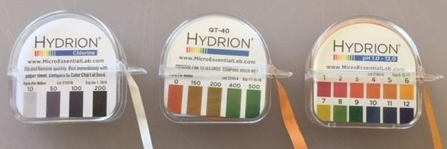
      - Acids
    - When using a chemical sanitizer, an appropriate method (e.g. test strips) must be utilized for measuring/testing the concentration of the chemical sanitizer during warewashing. Sanitizer strength must be used at concentration specified on manufacturer’s label.
Test strips for chlorine, quat, and acid sanitizers

- The action of warewashing generally involves the following steps:
- Scraping food debris from the food contact surface into a disposal or garbage container;
- Washing the food contact surface with hot soapy water;
- Rinsing the food contact surface in clean water;
- Sanitizing the food contact surface by immersing in an approved chemical sanitizing solution; and then
- Air drying the food contact surface

- Warewashing typically uses one of three methods.
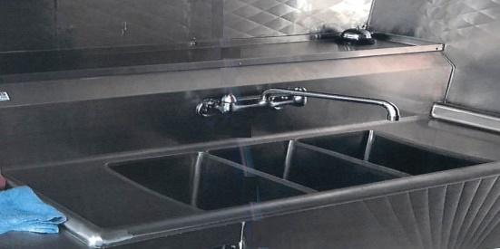
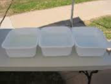
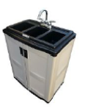
  - Manual warewashing- This is the use of compartments/basins into which the food contact surface (e.g. tongs, knives, spatulas, etc.) is submerged for washing, rinsing, and sanitizing. If manual warewashing is to be utilized on the STFU/mobile food establishment, then you must indicate on your layout plans the location of these compartments/basins and their size. The compartments/basins must be constructed of approved materials and designed to be easily cleanable. They must also be large enough to completely immerse the largest utensil or piece of equipment that will be cleaned and sanitized using this method. Additionally, enough space must be provided for the storage of both soiled utensils before they are cleaned and for proper air drying after sanitization. This storage space can consist of drainboards, racks, or tables. The location of this storage space for soiled items and air drying needs to be indicated on the layout plans of the unit.
Drainboards for storage of soiled and air drying of utensils
Temporary 3-compartment
set up
Portable 3-compartment set up

Fixed 3-compartment set up with drainboards

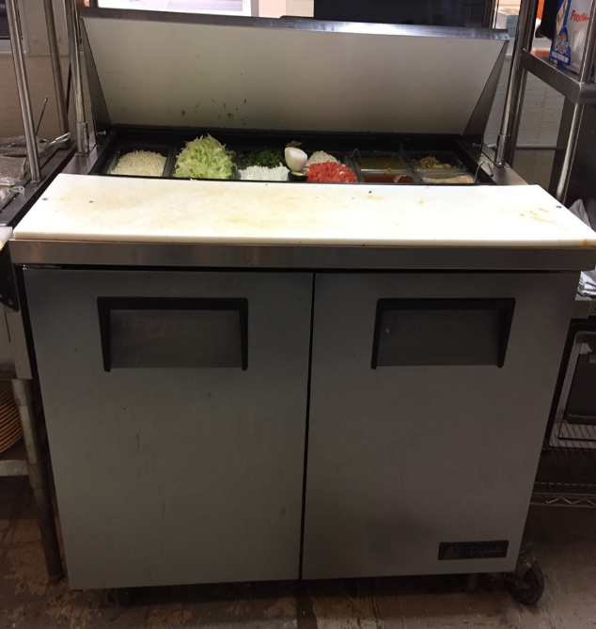
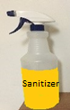
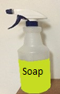
  - In-place warewashing-This is the warewashing of food contact surfaces of equipment (meat slicer, floor mixer, large cutting boards, food preparation sinks, etc.) and utensils that cannot fit into a compartment/basin for cleaning and sanitizing. Instead, warewashing is accomplished by cleaning, rinsing, and sanitizing at the location of the equipment. This is accomplished by utilizing separate containers/spray bottles of cleaning compound, rinse water, and sanitizer and applying these substances to the food contact surfaces of the equipment in the proper order of warewashing. If in-place warewashing is planned for the STFU/mobile food establishment, this must be indicated on the submitted plans.
Spray bottles used to substitute for wash, rinse, and sanitize
3. Sanitizer

2. Rinse
Cutting board is large and must be cleaned and sanitized in-place
1.Wash

  - Clean in place (CIP)- This warewashing method is the cleaning and sanitizing of food contact surfaces of equipment by the circulation or flowing of a cleaning solution, water rinse, and sanitizing solution onto or over equipment surfaces by mechanical means through a piping system. This type of warewashing is often utilized on frozen dessert machines. If a piece of proposed equipment needs to be cleaned and sanitized using a CIP method, this must be indicated on the submitted plans.

- Frequency of warewashing
  - Utensils and food contact surfaces of equipment need to be warewashed at appropriate frequencies. The frequency of warewashing is dependent upon the type of food the surface contacts and if this surface is in continual use. Following are requirements for warewashing frequency of food contact surfaces:
    - Before each use with a different type of raw animal food such as beef, fish, lamb, pork, or poultry;
    - Each time there is a change from working with raw foods to working with ready-to-eat foods;
    - Between uses with raw fruits and vegetables and with TCS food;
    - Before using or storing a food temperature measuring device;
    - At any time during the operation when contamination may have occurred;
    - Food contact surfaces that are in continual use and that contact TCS food must be cleaned and sanitized at least every 4 hours;
    - Food contact surfaces that contact non-TCS foods shall be cleaned:
      - At any time when contamination may have occurred;
      - At least every 24 hours for iced tea dispensers and consumer self-service utensils such as tongs, scoops, or ladles;
      - Before restocking consumer self-service equipment and utensils such as condiment dispensers and display containers; and
      - In equipment such as ice bins and beverage dispensing nozzles and enclosed components of equipment such as ice makers, cooking oil storage tanks and distribution line, beverage and syrup dispensing lines or tubes, coffee bean grinders, and water vending equipment
        - At a frequency specified by the manufacturer, or
        - Absent manufacturer specifications, at a frequency necessary to preclude accumulation of soil or mold.

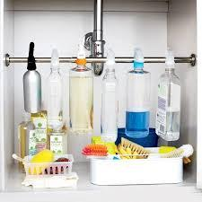
- Chemical (Poisonous or Toxic Material) Storage
  - Chemicals (detergents, degreasers, sanitizers, etc.) are typically needed in the operation of an STFU/mobile food establishment. If chemicals are mishandled or stored inappropriately it may lead to contamination of food or food contact surfaces. Chemicals stored on STFUs/mobile food establishments must:
    - Only be those chemicals needed for the operation and maintenance of the STFU/mobile food establishment;
Chemicals stored
under sink
Designated storage rack away from food/equipment/utensils
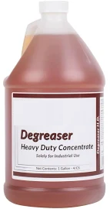
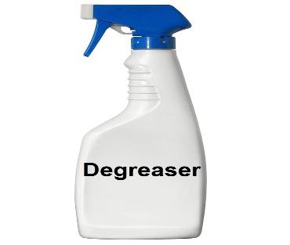
    - Be stored so they cannot contaminate food, equipment, utensils, linens, and single-use articles. This is accomplished by creating storage space (e.g. space below equipment or designated chemical storage rack/cabinet) on the unit, so the chemicals are located below these items.
    - Bulk containers (e.g. manufacturer’s container) of chemicals must bear a legible manufacturer's label. If chemicals are moved into a working container (e.g. spray bottle) from the bulk container, then this working container must be labeled with the common name of the chemical.
Supply bottle with manufacturer’s label
Labeled working container

STFU and Mobile Food Establishment Worksheet Help
Worksheet  Question #3 |  | Food Code &  Food Law | Guidance
Item A | Warewashing & Prep. Cooking Surfaces | FC 4-301.12, 4-301.13, 4-501.111, 4-501.114, 4-602.11, 4-602.12, 4-602.13, 4-603.14, 4-603.16, 4-702.11, 4-703.11, 4-901.11 | - On the worksheet, describe:  - How warewashing will be accomplished for all utensils and food contact surfaces of equipment.  - Designate if this warewashing will be done in basins/compartments, be in-place cleaning, or CIP.  - List the frequency of cleaning of utensils and food contact surfaces of equipment.  - Describe the sanitizer to be used and list the concentration as specified on manufacturer's label for that sanitizer.  - Mark that test strips for sanitizer shall be provided.
Item B | Chemical Storage | FC 7-101.11, 7-102.11, 7-201.11 | - On the worksheet describe how chemicals will be stored on the STFU/mobile food establishment so they will not contaminate food, equipment, utensils, linens, and single-use articles.  - If a separate cabinet or rack is planned for chemical storage, this cabinet/rack needs to be identified on the layout plans of the unit as the chemical storage area.
*FC =Michigan Modified Food Code. *FL = Food Law
To view the food code, food law and other fact sheets go to: http://www.michigan.gov/mdard/0,4610,7-125-50772_45851_61711---,00.html or call 800-292-3939 to request single free copies.

PART 4
WATER SUPPLY

Source
Water used for the STFU/mobile food establishment must come from an approved source. Approved sources include:
- Public water system;
- Commercial bottled water; or
- Regulated non-public water system (e.g. well) that is constructed, maintained, and operated according to law.
  - Contact your regulatory authority for additional information regarding non-public water systems and their usage for your unit.

Water supplied for the STFU/mobile food establishment must be of sufficient capacity to meet the water demands of the unit (e.g. handwashing, warewashing, food preparation, etc.).
Inspection Port-flanged upward ½” & equipped with a cover
Water Supply Storage Tank and Associated Hoses
- Storage tanks for drinking water must be:
  - Constructed of materials that are safe, corrosion-resistant, nonabsorbent, and finished to have a smooth, easily cleanable surface;
Tank Vent-pointed downward with 16 mesh screen or protective filter
  - Enclosed from the filling inlet to the discharge outlet and be sloped to an outlet that allows complete drainage of the tank;
Inlet- ¾” or less
  - The tank inlet shall be positioned so that it is protected from contaminants such as waste discharge, road dust, oil, or grease;
Outlet
Sloped to drain to outlet
  - The tank inlet shall be:
    - Three-fourths inch in inner diameter or less; and
    - Provided with a hose connection of a size or type that will prevent its use for any other service.
  - If provided, the water tank vent shall terminate in a downward direction and shall be covered with:
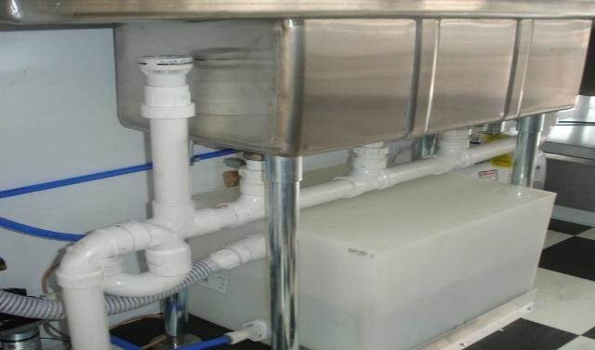
    - 16 mesh screen or equivalent when vent is in a protected area; or
    - A protective filter when the vent is in an area that is not protected from windblown dirt and debris.
  - If provided, an access port for inspection and cleaning of the tank shall:
Inlet
    - Be at the at the top of the tank;
    - Be flanged upward at least 1/2” inch; and
Outlet
    - Equipped with a cover assembly that is:
      - Provided with a gasket and device for securing the cover in place; and
Water tank under 3-comparmtent sink in unit
      - Flanged to overlap the opening and sloped to drain.
  - Size of the water storage tank depends upon the operations and water using equipment (e.g. handsinks, 3-compartment, beverage dispensers, etc.) of the STFU/mobile food establishment. Recommended guidance for water tank size is to provide a minimum of 5 gallons available for handwashing and then additional capacity to fill all other sinks (e.g. warewashing sinks) to 75% of their capacity. Work with your regulatory authority in that they may have additional guidance regarding appropriate size water storage tank.
  - If a water storage tank is utilized, the location of the tank needs to be indicated on the layout plans of the unit.

- Hoses utilized to convey drinking water from a water tank must be:
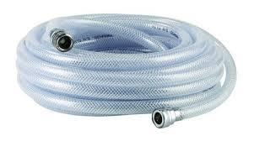
  - Constructed of materials that are safe (food grade), durable, corrosion-resistant, and non-absorbent;
  - Resistant to pitting, chipping, razing, scratching, scoring, distortion, and decomposition;
  - Finished with a smooth interior surface; and
  - Clearly identified as to its use if not permanently attached.

- Water supply storage tank and hoses both shall:
  - Have inlet and outlet fittings that, when not in use, are protected using a cover or device that is:
    - A cap and keeper chain;
    - Closed cabinet;
    - Closed storage tube; or
    - Other approved protective cover or device
  - Be flushed and sanitized before being placed in service, after construction, repair, modification, and periods of nonuse.
  - Be used for no other purposes aside from that of conveying drinking water.

Backflow Prevention-Water Supply Lines
Cross-Connections are any physical connections or arrangements between two otherwise separate piping systems, one of which contains potable water (e.g. water supply system/tank) and one of which contains non-potable water which is water of unknown or questionable safety. As a result of the cross-connection there exists the possibility for the flow from one system to the other, with the direction of flow depending on the pressure differential between the two systems. When a cross-connection is present it creates the potential for backflow which may introduce contaminants or pollutants into the potable water line. Ideally, it is best to not have any cross-connections, but in certain situations they are unavoidable. When an installation of equipment requires a cross-connection, it must be properly protected with an acceptable backflow prevention method to eliminate any potential for a reverse flow back into the potable water supply. An unprotected cross-connection threatens the health and safety of individuals and may contaminate food or beverage products utilizing water from that system. Two types of cross-connections exist:

- Direct Connection: a cross-connection that is subject to both backpressure and backsiphonage.
- Indirect Connection: a cross-connection that is only subject to backsiphonage.

Backflow is a reversal in flow of water that is opposite to the expected or intended direction. The reversal in flow is undesirable. However, a properly protected system can remain safe. There are two types of backflow:

- Backpressure: occurs when both systems (potable water supply and non-potable) are under pressure. Backflow occurs when the non-potable system has greater pressure than the potable water supply system/tank. This pressure differential pushes possible contaminants or pollutants from the non-potable system into the potable water supply/tank. Principle causes include:
  - Thermal expansion of the water (boiler)
  - High pressure generated by pumps downstream (e.g. carbonator pumps)
  - Elevation

- Backsiphonage: occurs when the pressure in the potable water supply system/tank drops below atmospheric pressure and water is drawn or siphoned from the non-potable system into the potable water supply/tank. Principle causes include:
  - Undersized sections of pipe can create an aspirator effect in the restricted area.
  - A break or repair in a supply line can create a vacuum (as gravity drains the water out) on the elevated portions of the system above the affected area.
  - A high-water withdrawal, such as firefighting or water main flushing, can create a vacuum. The withdrawal is more likely to create stronger negative pressure at the higher elevation of the system. This can occur if your STFU/mobile food establishment does not have an on-board self-contained water system and relies upon a direct connection to a public water main for water supply.

Backflow from the non-potable system to the potable water supply system/tank can be prevented by physical or mechanical means:

- Physical backflow prevention is the installation of an air gap. An air gap is the most desirable method of backflow prevention. It is simple, economical, non-mechanical, fail safe, and can be used for potential backsiphonage and backpressure applications. An air gap is the unobstructed vertical air space that separates the end of a supply line and the flood level rim of a receptacle. The receptacle may be a sink, coffee urn, steam kettle, dipper well, etc. The air gap must be the greater of the two – a minimum of 1 inch or twice the diameter of the supply pipe.
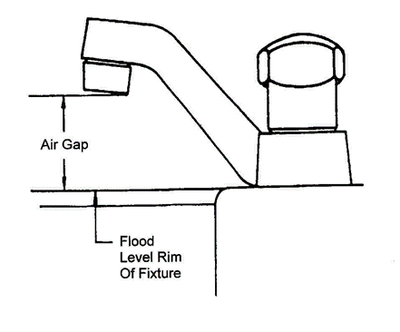
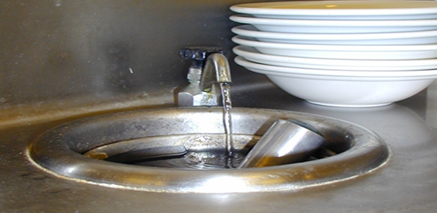

Air gap between water supply line and flood rim of receptacle
- Mechanical backflow prevention is the installation of a backflow assembly/device. The type of mechanical backflow assembly/device needed must be appropriate for the degree of hazard and specific application (prevention against potential backsiphonage, backpressure, or both). Backflow prevention device shall be located so that it may be serviced and maintained. All backflow prevention devices are required to be constructed and utilized according to American Society of Sanitary Engineers (ASSE) standards. Backflow prevention devices must be installed according to their manufacturer’s specifications. The level of hazard is a consideration in the selection of the appropriate device.
  - High Hazard situations occur when potential contamination can be introduced into the potable water system. Contamination is an impairment of the quality of the potable water that creates an actual hazard to the public health through poisoning or the spread of disease by sewage, industrial fluids or waste. Examples of contaminants include pesticides, chemicals, and infectious microorganisms.

  - Low Hazard situations occur when potential pollution can be introduced into the potable water system. Pollution is an impairment of the quality of the potable water to a degree that does not create a hazard to public health but that does adversely and unreasonably affect the aesthetic quality of such potable water for use. Examples of pollutants are turbidity, food, beverages, and food coloring.

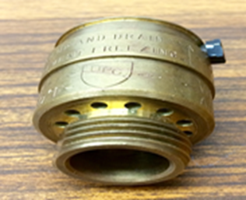
  - Types of mechanical backflow prevention assembly/devices and usage:
    - Hose Bib Vacuum Breaker (ASSE 1011)
      - Can be installed on the end of a hose bib (sill cock, boiler drain, etc.) or anywhere a hose can be connected.
      - Shut-off valves must be located upstream from the vacuum breaker with no shut-off valves downstream that may put it under constant pressure.
      - Spring loaded shut-off valves must be removed when the hose in not in active use.
      - Approved for high and low hazards, non-continuous pressure, and protection against backsiphonage only.

    - Atmospheric Vacuum Breaker (ASSE 1001)
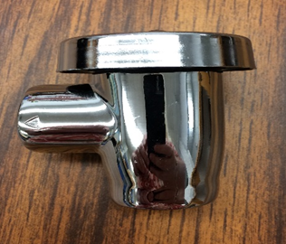
      - An atmospheric vacuum breaker works like a hose bib vacuum breaker and is typically found at mop sinks, spray nozzles, dishmachines, areas where a hose can be connected.
      - Must be installed vertically and be elevated at least 6 inches above the highest source of contamination downstream of the unit.
      - Shut-off valves must be located upstream of the unit with no shut-off valves downstream that may put it under constant pressure.
      - Approved for high and low hazards, non-continuous pressure, and protection against backsiphonage only.

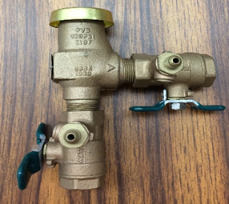
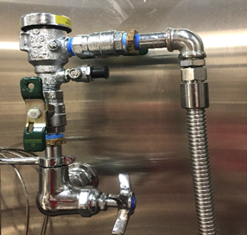
    - Pressure Vacuum Breaker (ASSE 1020 and ASSE 1056)
      - The pressure vacuum breaker is like the atmospheric vacuum breaker except that it can be tested for functionality and be can be under constant pressure.
      - It must be installed according to manufacturer’s instructions in reference to the highest elevated inlet or fixture on its downstream side. The device must be located to be accessible for testing and serving.
      - The device can be under constant pressure and may have shut off valves located upstream and downstream of the device.
      - Approved for high and low hazards, continuous pressure, and protection against backsiphonage only.

    - Double check valves with Intermediate Atmospheric Vent (ASSE 1012 and ASSE 1022)
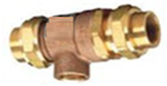

ASSE 1012
ASSE 1022
      - Vented double check backflow preventers are installed on water supply lines to foodservice equipment, in which a high hazard is not present, to ensure that carbonated water, food particles, beverages, etc. do not enter the potable water supply system/tank.
      - A backflow preventer constructed to ASSE 1022 standards must be used on water lines connected to a carbonator.
      - FC section 5-203.14 stipulates that a 100-mesh screen must be installed on the upstream side of the ASSE 1022 device when installed on a water line to a carbonator. This protects the device from particles in the water supply. The 100-mesh screen may be located with the ASSE 1022 device, within the carbonator pump, or as an attachment such as shown in the picture on the next page (the black “Y” is the added screen for this ASSE 1022).
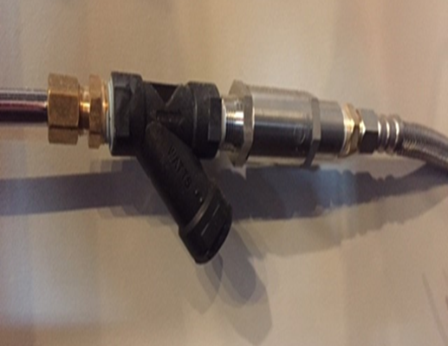
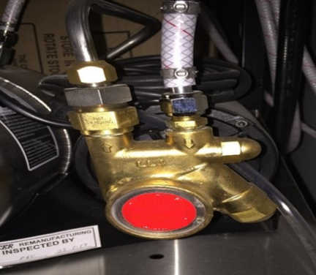
      - Shut off valves may be located upstream and downstream of this device.

ASSE 1022

Screen

      - If the relief port is piped to a drain, the piping must be air gapped at the drain.
      - Approved for low hazard only, continuous pressure, and protection against backpressure and backsiphonage.

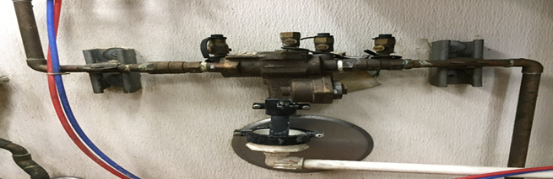
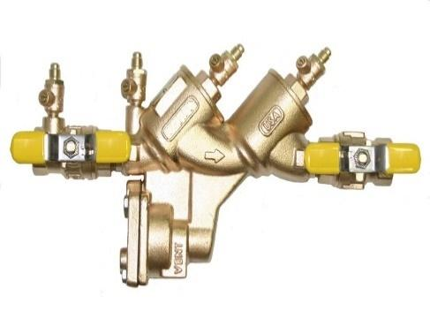
    - Reduced Pressure Zone Backflow Prevention Assembly (RPZ) (ASSE 1013)
      - An RPZ provides the maximum protection, aside from an air gap, against both backsiphonage and backpressure.
      - The unit must be accessible for testing and service.
      - This device can be under constant pressure and may have shut off valves located upstream and downstream of the device.
      - It can be installed lower than the potential source of contamination. Refer to the manufacturer’s installation instructions.
      - If the relief port is piped to a drain, the piping must be air gapped at the drain.
      - Approved for high and low hazards, continuous pressure, and protection against backpressure and backsiphonage.

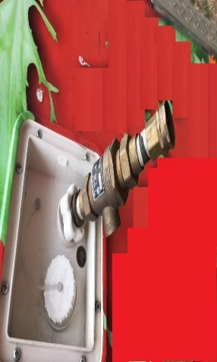
Work with your regulatory authority regarding which backflow prevention device, if needed, is best suited for equipment within your unit. It is advisable to work with/seek guidance from your area plumbing regulator or a licensed/registered plumber in determining what type of backflow prevention device is best suited for equipment within your STFU/mobile food establishment.

Public Water Connection
If a water supply hose is used to connect your STFU/mobile food establishment to a public water supply system, additional backflow prevention may be needed at the connection point to protect the public water supply from possible contamination from the STFU/mobile food establishment. Consult with your regulatory authority regarding appropriate methods for protection of public water supply.
Backflow preventer installed on exterior of unit for connection of public water line

NOTE: It is the responsibility of the STFU/mobile food establishment operator to check with the local jurisdiction in which they will be operating regarding additional backflow prevention requirements that may be required beyond the Michigan Modified Food Code and Food Law.

STFU and Mobile Food Establishment Worksheet Help
Worksheet  Question #4 |  | Food Code &  Food Law | Guidance
Item A | Water Source and Storage | FC 5-101.11, 5-102.11, 5-103.11, 5-104.11, 5-104.12, 5-301.11, 5-302.11, 5-302.12, 5-302.14, 5-302.15, 5-302.16, 5-303.13 | - On the worksheet, describe:  - The source of potable water that will be used.  - How this potable water will be supplied/delivered to the unit. This would include a description of any support equipment used to obtain/deliver the water (e.g. food grade hoses).  - How water will be stored within the unit (e.g. water holding tanks, containers, etc.). This would include the size of the water holding tanks or water containers to be used.
Item B | Cleaning and Sanitizing of Water Supply Equipment | FC 5-303.12, 5-304.11, 5-304.13 | - On the worksheet describe:  - How equipment used to hold (e.g. water holding tanks) or supply water (e.g. food grade hoses) for the unit will be cleaned and sanitized.  - List the frequency in which this cleaning and sanitizing will take place.  - List how equipment used to hold or supply water will be protected from contamination when not in use.
Item C | Backflow Prevention | FC 5-202.13, 5-202.14, 5-203.14, 5-203.15, 5-202.13, 5-304.12 | - On the worksheet describe:  - What equipment (e.g. sinks, carbonators), etc.) will have a potable water line connection within the unit and what type of backflow prevention (e.g. air gap, mechanical backflow preventer) will be provided between the water line and the equipment.  - If the unit is to have a water supply line connected to a public water system, describe what backflow prevention methods will be utilized to protect the public water system from the unit.
*FC =Michigan Modified Food Code. *FL = Food Law
To view the food code, food law and other fact sheets go to: http://www.michigan.gov/mdard/0,4610,7-125-50772_45851_61711---,00.html or call 800-292-3939 to request single free copies.

PART 5
SEWAGE DISPOSAL
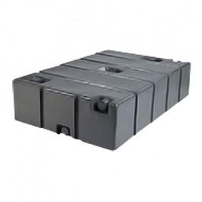
Holding and Disposal
Sewage (including water from handwashing, warewashing, food preparation, cleaning, etc.) from the STFU/mobile food establishment must be appropriately collected (e.g. holding containers/tanks) and disposed of at an approved waste servicing area (e.g. RV disposal site, mop sink of a commissary, etc.) or by a sewage transport vehicle in such a way that does not create a public health hazard or nuisance. Disposal sites must be planned and pre-approved if not provided at event locations.
Waste water tank that can be attached to unit
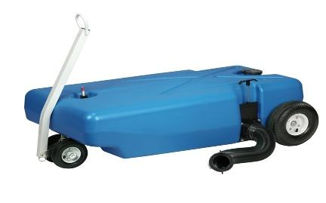
A sewage holding tank on the STFU/mobile food establishment shall be:
- Sized to be 15% larger in capacity than the water supply tank; and
- Sloped to a drain that is one inch in diameter or greater and equipped with a shut-off valve.
- If a sewage holding tank is utilized, the location of the tank needs to be indicated on the layout plans of the unit.
Waste water tank that is portable

Backflow Prevention-Drain lines from Equipment
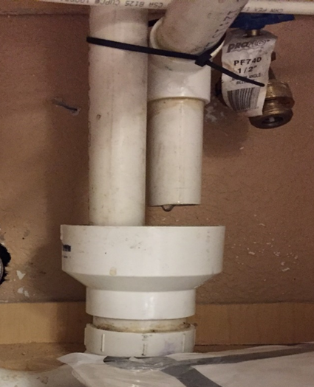
Within the STFU/mobile food establishment, for equipment that has a drainline, a direct connection may not exist between the sewage system (sewage holding tank or collection container) and the drain originating from equipment in which food, portable equipment, or utensils are placed. The drainline from ice storage bins and ice machines shall not be directly connected with another drainline and shall be drained through an air gap to the sewage disposal system (sewage holding tank or collection container).
Air gap: drain line above flood rim of waste receptacle
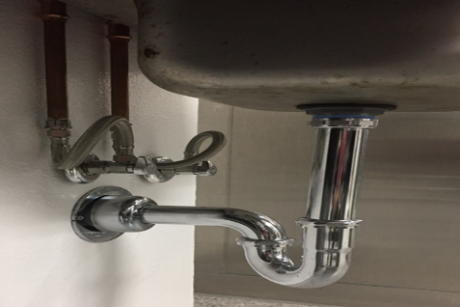
Air break: drain line below flood rim of waste receptacle

Indirect connection (air gap or air break)- permitted on equipment in which food, portable equipment or utensils are placed. Drainline off ice bins/machines must be through an air gap.
Direct connection-not permitted on equipment in which food, portable equipment or utensils are placed
Flood rim of waste receptacle
Toilets
At least one toilet shall be provided for employees. If an onboard toilet is not provided, then events/locations the STFU/mobile food establishment is operating must have toilet facilities. A handwash station shall be in or immediately adjacent to toilet rooms.

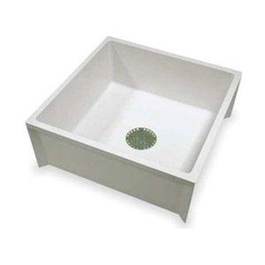
Service Sink
  - If applicable to the operation of the STFU/mobile food establishment, one service sink or curbed cleaning facility equipped with a floor drain shall be provided for the cleaning of mops or similar wet floor cleaning tools and the disposal of mop water and similar liquid wastes. If a service sink is utilized, the location of the service sink must be indicated on the layout plans of the unit. If a service sink is not proposed, the operator will need to indicate how floor cleaning will take place and where liquid waste water will be disposed.
STFU and Mobile Food Establishment Worksheet Help
Worksheet  Question #5 |  | Food Code &  Food Law | Guidance
Item A | Liquid Waste Disposal | FC 5-401.11, 5-402.14 | - On the worksheet, describe how liquid waste will be collected and where it will be disposed. List the size of waste holding tanks/containers.
Item B | Backflow Prevention | FC 5-402.11  FL 6125 | - On the worksheet:  - List the equipment that has a drainline, in which food, portable equipment, or utensils are placed.  - Describe how the drainlines of this listed equipment will be protected (e.g. air gap, air break) from backflow from the sewage holding system.
Item C | Toilet Facilities | FC 5-203.12, 5-204.11 | - On the worksheet describe how employees will have access to toilet facilities and adjacent handwash stations while unit is in operation.
Item D | Service Sink | FC 5-203.13 | - On the worksheet, describe how floors will be cleaned and where waste water from wet floor cleaning will be disposed, if applicable to the operation of the unit.
*FC =Michigan Modified Food Code. *FL = Food Law
To view the food code, food law and other fact sheets go to: http://www.michigan.gov/mdard/0,4610,7-125-50772_45851_61711---,00.html or call 800-292-3939 to request single free copies.

PART 6
Environmental Hazards
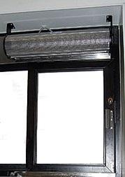
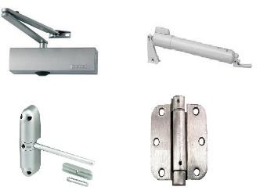
Pest & Environmental Controls
Adequate measures must be taken to control pests (e.g. insects, rodents, etc.) and environmental elements (e.g. leaves, windblown dust) from infesting/contaminating an STFU/mobile food establishment during operation and storage. Methods for protecting the unit and food and food contact surfaces from pests and environmental elements include but not limited to:
Various self-closures for doors
Air curtain over pass through window
- Installing air curtains on outer openings of unit (e.g. doors, windows);
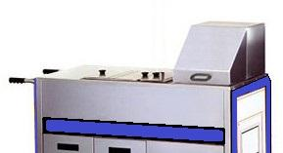
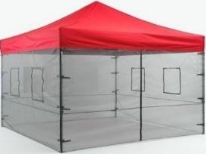
- Providing solid or screened (16 mesh or finer) self-closing doors;
- Providing solid or screened (16 mesh or finer) windows. It is recommended that windows be self-closing;
- Keeping food in packages or in covered (lidded) containers; or
Covered food containers
Screed in area
- Other proposed effective means

Effective control methods will vary based upon the operations and design of the proposed STFU/mobile food establishment. Verify with your regulatory authority regarding what controls methods would be acceptable.

STFU and Mobile Food Establishment Worksheet Help
Worksheet  Question #6 |  | Food Code &  Food Law | Guidance
Item A | Pest & Environmental Element Controls | FC 6-202.15, 6-202.16, 6-501.111 | - On the worksheet, describe:  - How flying and crawling pests as well as environmental elements will be kept out of the unit.  - Describe how equipment and/or food that is in the open air will be protected.
*FC =Michigan Modified Food Code. *FL = Food Law
To view the food code, food law and other fact sheets go to: http://www.michigan.gov/mdard/0,4610,7-125-50772_45851_61711---,00.html or call 800-292-3939 to request single free copies.

PART 7
Floors/Walls/Ceiling

Floors
If applicable to the STFU/mobile food establishment, indoor floors must be constructed out of a material that is durable, smooth, non-absorbent, and easily cleanable. Acceptable flooring material includes but is not limited to:
- Commercial grade vinyl tile
- Commercial grade sheet vinyl
- Quarry tile
- Stainless steel
- Poured seamless epoxy
- Coin mat/rubber flooring

If the STFU/mobile food establishment will not have an installed floor, then the unit must be placed upon an acceptable surface while operating to prevent contamination of food and equipment from dirt and mud. Acceptable surfaces include but not limited to:
- Concrete
- Asphalt
- Cleanable mats
- Duckboards

Walls
If applicable to the STFU/mobile food establishment, installed indoor walls must be constructed out of a material that is durable, smooth, non-absorbent, and easily cleanable. Acceptable wall material includes but is not limited to:
- Stainless steel
- Fiberglass reinforced panels (FRP)
- Sealed drywall
- Ceramic tile

If the STFU/mobile food establishment will not have installed walls, then adequate protection must be provided to shield food and equipment from the weather, dust, pests, and other environmental contaminants. Acceptable protection measures include but are not limited to:
- Screening (16 mesh or finer)
- Canvas, tarps, plastic sheeting
- Lidded food equipment that provides protection

Ceiling
If applicable to the STFU/mobile food establishment, installed indoor ceilings must be constructed out of a material that is durable, smooth, non-absorbent, and easily cleanable. Acceptable ceiling material includes but is not limited to:
- Stainless steel
- Fiberglass reinforced panels (FRP)
- Sealed drywall
- Dropped ceiling tile

If the STFU/mobile food establishment will not have an installed ceiling, then overhead protection must be provided to protect food and equipment from the weather, dust, pests, and other environmental contaminants. Acceptable protection measures include but not limited to:
- Overhead umbrellas/canopies
- Canvas, tarps, plastic sheeting
- Lidded food equipment that provides protection

Exterior
Exteriors of STFU/mobile food establishments must be constructed of weather-resistant materials.

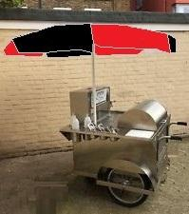
Weather resistant metal exterior
Stainless steel lidded containers to protect food and food contact surfaces
Canvas umbrella
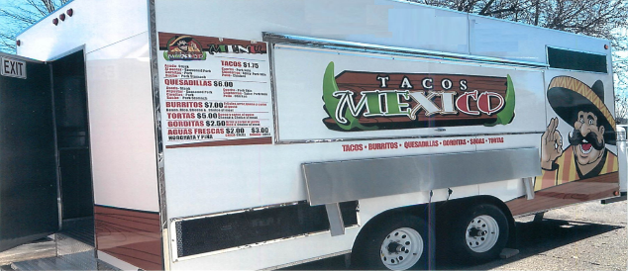

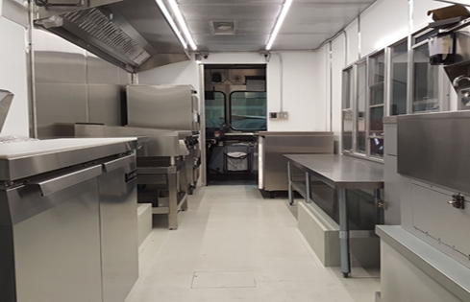
Weather resistance stainless steel exterior
Painted metal floor
Located on asphalt
Solid/screened pass through windows
FRP and stainless-steel walls
Stainless steel ceiling
STFU and Mobile Food Establishment Worksheet Help
Worksheet  Question #7 |  | Food Code &  Food Law | Guidance
Item A | Floor | FC 6-101.11, 6-201.11, 6-201.13, 6-201.15 | - On the worksheet describe:  - Type of indoor flooring to be installed.  - If installed flooring is not applicable, list what type of ground surface the STFU/mobile food establishment will be placed upon when operating.
Item B | Walls | FC 6-101.11, 6-201.11, 6-201.16, 6-201.17 | - On the worksheet describe:  - Type of indoor walls to be installed.  - If walls are not being installed, describe how food equipment and food will be protected from the surrounding environment.
Item C | Ceiling | FC 6-101.11, 6-201.11, 6-201.16, 6-201.17 | - On the worksheet describe:  - Type of indoor ceiling to be installed.  - If ceiling is not being installed, describe how overhead protection will be provided.
Item  D | Exterior | FC 6-102.11 | - On the worksheet describe the exterior construction material of the unit.
*FC =Michigan Modified Food Code. *FL = Food Law
To view the food code, food law and other fact sheets go to: http://www.michigan.gov/mdard/0,4610,7-125-50772_45851_61711---,00.html or call 800-292-3939 to request single free copies.

PART 8
Equipment Specifications

Food Equipment
Food equipment needs be constructed of appropriate materials that can withstand repeated washing and be designed to allow easy cleaning. Food equipment that is certified or classified to NSF/ANSI Standards for sanitation by an ANSI accredited certifier (e.g. NSF, UL, ETL, CSA, etc.) is deemed to comply with construction and design requirements of the Michigan Modified Food Code. For custom made items (such as countertops or grills), in the submitted plans indicate the type of material the items will be constructed of. Food contact surfaces of equipment shall be made from materials that are:
- Safe;
- Durable, corrosion-resistant, and nonabsorbent;
- Sufficient in weight and thickness to withstand repeated warewashing;
- Finished to have a smooth, easily surface; and
- Resistant to pitting, chipping, crazing, scratching, scoring, distortion, and decomposition.

The design of multi-use food contact surfaces shall be:
- Smooth;
- Free of breaks, open seams, cracks, chips, inclusions, pits, and similar imperfections;
- Free of sharp internal angles, corners, and crevices;
- Finished to have smooth welds and joints; and
- Accessible for cleaning and inspection.

Food equipment must be installed to allow ease of cleaning around it. This can be accomplished by:
- Providing sufficient space beneath, above, and on the sides of equipment that is floor or counter mounted by:
  - For counter mounted equipment, provide at least four inches between the bottom of the equipment and the counter it is placed upon;
  - For floor mounted equipment, provide at least six inches between the bottom of the equipment and the floor it is place upon;
  - Providing spacing behind, on the sides, and above equipment sufficient to reach in and clean the sides, back, and top of equipment;
- Installing equipment on castors/wheels to move for cleaning; or
- Sealing counter mounted and floor mounted equipment to adjacent floors, walls, or equipment to prevent debris from accumulating underneath, behind, or on the sides of the equipment.
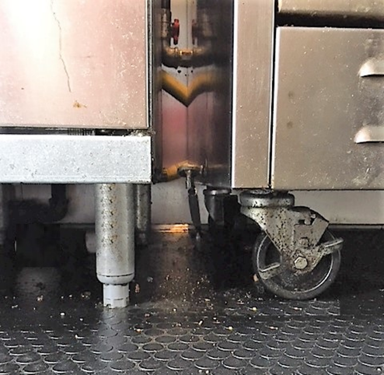
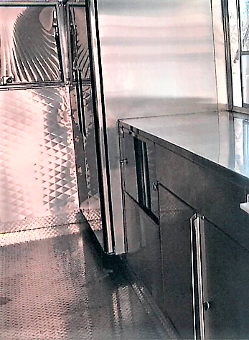
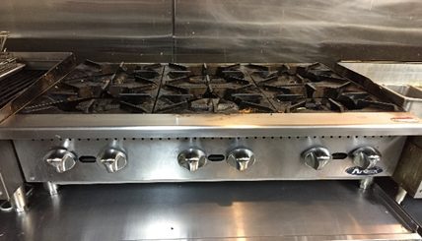
Floor mounted equipment elevated on 6-inch legs or on castors to move for cleaning.
Equipment sealed to each other, floor, and back wall to prevent debris from accumulating underneath, behind and between equipment.
Counter top equipment elevated on 4-inch legs to provide space for cleaning underneath
Food equipment of sufficient capacity must be provided to support your intended menu and food preparation methods. The more complex the menu and/or food preparation methods, the greater the equipment needs. Items to consider when determining equipment needs/capacity include but are not limited to:
- Cold holding space for maintaining temperature and/or cooling TCS foods;
- Sufficient cooking/reheating equipment to bring TCS foods up to proper cooking/reheat temperatures;
- Hot holding space for maintaining temperature once food is cooked or reheated;
- Sufficient food cutting/assembly surfaces (e.g. cutting boards, preparation tables);
- Sufficient space to prevent cross contamination between raw animal foods and ready to eat foods while in cold storage or when being prepared/assembled; and
- A sufficiently sized warewashing sink, if applicable to the STFU/mobile food establishment, along with enough space for the temporary storage of dirty utensils and the air drying of clean utensils.

The location of all food equipment and warewashing sinks needs to be indicated on your layout plans.

Hot Water Capacity
Hot water of sufficient temperature and capacity is required for various procedures/processes. Handwashing stations require a minimum water temperature of 100°F, while water used in the cleaning step of warewashing utensils and food contact surfaces of equipment, typically needs to be at least 110°F. Hot water must be provided to the STFU/mobile food establishment during all times of operation. Methods for providing hot water include but are not limited to:
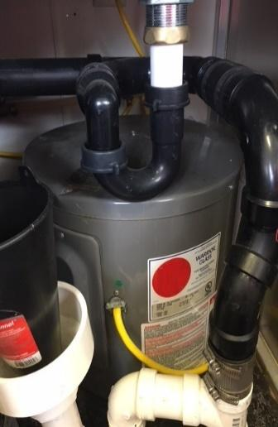
- Installation of tank water heater;
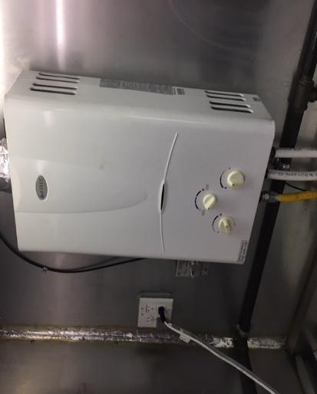
  - The tank must be of sufficient size to fill the 3-compartment basins utilized for warewashing, if applicable to STFU/mobile food establishment, and still provide constant warm water for handwashing.
- Installation of tankless water heater;
  - Ensure tankless water heater is rated for providing potable water and is installed according to manufacturer's instructions.
- Provide equipment which can heat water that is then transferred to containers/equipment that utilizes hot water (e.g. 3-compartment warewashing set up, temporary handwash station).
Tankless water heater
Tank water heater
  - This method is typical used for STFU/mobile food establishments that are a tent style set up.

When installing a hot water generating device, the location of this device must be indicated on the layout plans of the STFU/mobile food establishment.

Dish (Warewashing) Sinks
Dish (warewashing) sinks are utilized for the cleaning and sanitizing of utensils and equipment, see Part 3 of this manual. If utensils and equipment are intended to be washed within the STFU/mobile food establishment, then dish (warewashing) sinks need to be provided on the STFU/mobile food establishment. Dish (warewashing) sinks may not be necessary for a mobile food establishment if the commissary that the mobile food establishment returns to every 24 hours is equipped with dish (warewashing) sinks. Dish (warewashing) sinks shall be:
- Constructed from corrosion-resistant, nonabsorbent, and smooth material;
- Durable to retain their characteristic qualities under normal use conditions;
- Designed to be free of unnecessary ledges, projections, and crevices, and designed and constructed to allow easy cleaning and to facilitate maintenance.
- Appropriately sized to accommodate the largest piece of equipment or largest utensil that will be clean and sanitized in the dish (warewashing) sinks.

Portable basins that substitute for dish (warewashing sinks) may be used under certain circumstances such as for tent style STFU/mobile food establishments. The location of dish (warewashing) sinks, if applicable, must be indicated on the layout plans of the STFU/mobile food establishment.

Remember that enough space must be provided for the storage of both soiled utensils before they are cleaned and for proper air drying after sanitization.

STFU and Mobile Food Establishment Worksheet Help
Worksheet  Question #8 |  | Food Code &  Food Law | Guidance
Item A | Food Equipment | FC 4-101.11, 4-101.19, 4-201.11, 4-202.11, 4-202.16, 4-301.11, 4-402.11, 4-402.12, | - On the worksheet:  - List all food equipment (e.g. cold holding, hot holding, cooking, etc.) along with make and model of equipment. Equipment specification sheets are recommended as part of your plan review submittal.  - List if the equipment will be floor or countertop mounted.
Item B | Hot Water Capacity | FC 5-103.11 | - On the worksheet describe:  - How hot water will be provided for the STFU/mobile food establishment.  - If a tank or tankless water heater will be utilized, indicate the make, model, and size of unit. Provide manufacturer’s specifications if available.
Item C | Dish (Warewashing) Sinks | FC 4-301.12, 4-301.13 | - On the worksheet:  - List the size of each sink compartment or tub to be used for warewashing. Recommended to provide manufacturer’s specifications.  - List the measurements of the largest piece of equipment or largest utensil that will be paced into the sink compartments for warewashing. Sink compartments need to be large enough to accommodate this equipment/utensil.  - Describe where soiled utensils/equipment will be stored before warewashing and where cleaned and sanitized utensils/equipment will be air dried.
*FC =Michigan Modified Food Code. *FL = Food Law
To view the food code, food law and other fact sheets go to: http://www.michigan.gov/mdard/0,4610,7-125-50772_45851_61711---,00.html or call 800-292-3939 to request single free copies.

PART 9
Electricity

If your STFU/mobile food establishment will be utilizing equipment (e.g. water heater, refrigeration, ventilation hood, pumps, etc.) that is dependent upon electricity, then an electrical power supply of sufficient capacity needs to be provided. Electricity can be supplied by a generator that is part of your STFU/mobile food establishment or an electrical hook up provided by another entity at the food service site. If the STFU/mobile food establishment is solely going to rely upon electrical hookup provided by another entity to run electrical equipment, then the STFU/mobile food establishment may be limited to only food service sites in which electrical hook up is available.

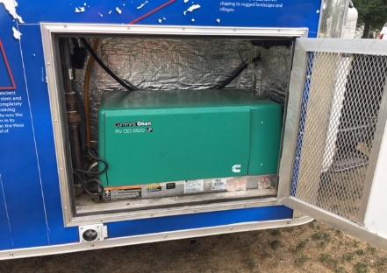
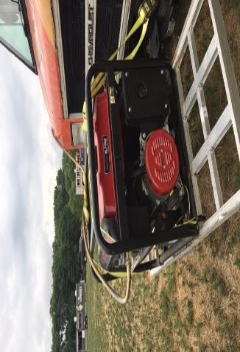
For generators, it is important that the power (wattage) supplied by the generator is of sufficient capacity to meet the simultaneous power (wattage) demand of all the electrical equipment of the STFU/mobile food establishment. A method for determining if a generator will be sufficient in size for the STFU/mobile food establishment is to total up the wattage of all electricity using equipment and compare this to the power (wattage) provided by the generator. Power (wattage) demand of equipment can often be found in equipment specification sheets or in the user manual. Keep in mind that some equipment (e.g. refrigerators) have a running (continuous) wattage demand and a starting (peak) wattage demand. When totaling up the wattage, you want to take into account the starting (peak) wattage demand. The generator also needs to be located/installed so it is separated from the food preparation and storage areas and is accessible for cleaning and maintenance. It is recommended to work with a licensed electrician in determine the electrical demand of the STFU/mobile food establishment and in determining the appropriately sized generator.
Generator installed outside of unit
Generator installed in exterior compartment of unit

If utilizing an electrical hook up provided by another entity at a food service site, it is important that supplied electrical power is of sufficient capacity to meet demands of STFU/mobile food establishment and is constantly supplied. This is especially important if equipment (e.g. refrigeration) will be run overnight at the food service site.

STFU and Mobile Food Establishment Worksheet Help
Worksheet  Question #9 |  | Food Code &  Food Law | Guidance
Items A | Electricity | FC 4-301.11 | - On the worksheet:  - Indicate if electricity will be required for the operation of the STFU/mobile food establishment.  - If electricity is required:  - Indicate the source of electrical power (e.g. generator and/or electrical hook up provided by another entity).  - If utilizing an electrical hook up, describe how you will ensure electricity is left running overnight if applicable.
*FC =Michigan Modified Food Code. *FL = Food Law
To view the food code, food law and other fact sheets go to: http://www.michigan.gov/mdard/0,4610,7-125-50772_45851_61711---,00.html or call 800-292-3939 to request single free copies.

PART 10
Mechanical Ventilation

Mechanical ventilation for the removal of effluent (heat, steam, condensation, vapors, obnoxious odors, smoke, fumes) from equipment may be required for a STFU/mobile food establishment. The need for mechanical ventilation is dependent upon the design, equipment, menu, and operations of the STFU/mobile food establishment. Following is a guidance decision tree for helping determine if mechanical ventilation is needed for the STFU/mobile food establishment.

Is there equipment (e.g. cooking, reheating, hot holding, etc.) that will generate effluent (e.g. heat, steam, condensation, vapors, obnoxious odors, grease, smoke or fumes)?
NO
Mechanical ventilation may not be needed

YES

Is this equipment located within an enclosed STFU/mobile food establishment that could to trap the effluent within unit?
NO

YES
Mechanical ventilation may be needed

You will need to work with your regulatory authority in deciding if mechanical ventilation is required. If needed, the mechanical ventilation hood must be indicated on the layout plans of the unit.
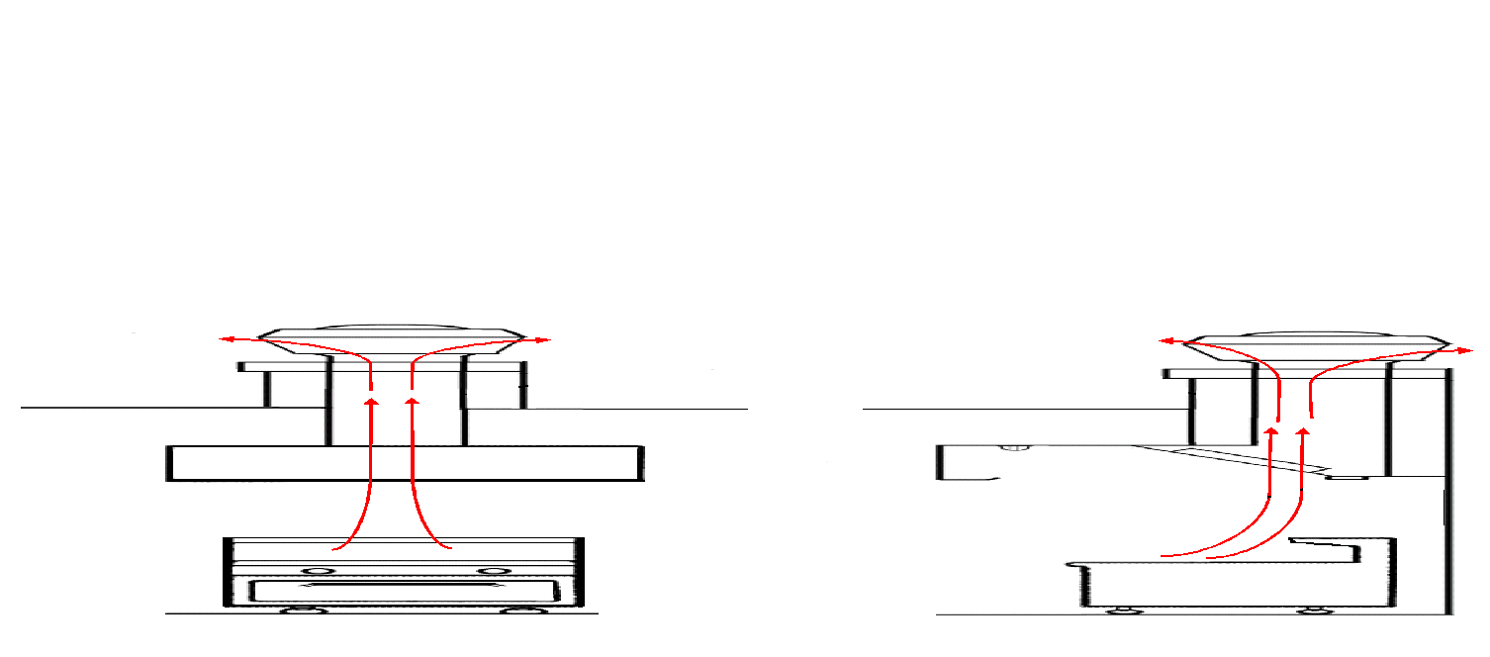
Effluent producing equipment located completely underneath hood
Grease collection channel that drains it to removable collection cup
Baffle grease filter collects grease and drains it to channel
Hood that captures effluent
Front View
Side View
Basic Diagram of Type I
Ventilation Hood
Roof
Exhaust duct
Exhaust fan draws effluent out of unit
Effluent
exhausted out
Effluent
exhausted out
Construction and Design
A ventilation hood needs to be constructed of materials that are corrosion-resistant, nonabsorbent, durable, and smooth. Stainless steel is a typical construction material. The ventilation hood needs to be free of unnecessary ledges, projections, and crevices and it must be designed and constructed to allow easy cleaning and to facilitate maintenance. It must also be designed to prevent grease or condensation from draining or dripping onto food, equipment, utensils, linens, and single use articles. If vented to the outside, the ventilation may not create a public health hazard, nuisance, or unlawful discharge.

Capacity
The ventilation hood system must be of sufficient capacity to capture and exhaust effluent from the STFU/mobile food establishment. As effluent is generated and rises, it should be captured by the hood and removed by the suction of the exhaust fan. A ventilation hood system may not effectively capture effluent if a hood is of improper size, the hood is not installed at appropriate height from equipment, equipment is not placed appropriately underneath the hood, or the exhaust fan is undersized. This can lead to grease and condensate build up causing unsanitary conditions and possibly cause deterioration of walls and ceilings. This accumulation of grease and condensate may also contaminate food and food-contact surfaces as well as present a possible fire hazard. Additionally, inadequate capturing of effluent may result in difficulty breathing in the work space. The amount of air that is needed to be removed by the ventilation hood system is known as the exhaust rate and is expressed as cubic feet per minute (CFM). The needed exhaust rate of your ventilation hood system is dependent on several factors such as the type of cooking equipment being used and the types of food you work with. For example, open-flame cooking equipment produces more effluent then a griddle, while cooking of fatty foods produces more grease/effluent then cooking of non-fatty foods. Another item that can affect exhaust rate is if the ventilation hood is listed or unlisted, see “Classification of Hoods”.

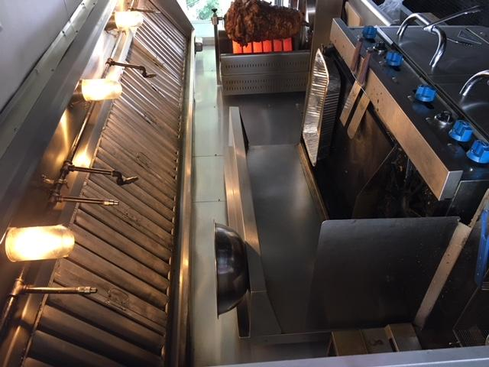
Since air (effluent) is exhausted by the ventilation hood system, new air of equal volume, known as makeup air, needs to be brought in from the outside to balance so that negative pressure is not created. Negative pressure can result in the ventilation hood system not working properly, as well as air being pulled from undesirable locations of the STFU/mobile food establishment such as drain pipes that lead to the wastewater tank. Negative pressure can also affect pilot lights on cooking equipment and water heaters causing them to go out. Make up air can be provided in an STFU/mobile food establishment by having screened windows or doors through which new air will be pulled in to replace the air that is exhausted out. However, if the STFU/mobile food establishment will be completely sealed (no screened windows and/or doors) or will operate during times of the year (e.g. winter) in which screened windows and doors are completely sealed, then a makeup air system may need to be installed as part of the ventilation hood system. To determine if enough makeup air is being provided, it is recommended to have an air balance test done by a licensed ventilation installer.
Type I hood over grease producing cooking equipment
Classification of Hoods

Type I ventilation hoods are intended to be used above smoke and/or grease producing equipment. They are designed to remove condensation, heat, smoke, along with grease and oil-laden vapors produced by cooking. Type I hoods have grease filters (baffle type) for capturing particulates and grease which then drain into a trough that empties into a collection cup. Mesh grease filters are not permitted due to lack of cleanability and restricted air flow as they become clogged with grease. Type I hoods can be listed or unlisted. Listed ventilation hoods have been built to a set standard and tested against Underwriters Laboratories (UL) standard #710 for performance in capturing smoke and vapor at various temperatures, ability to withstand fire conditions, and electrical components survivability in the application. It is recommended that only listed hoods be installed within a STFU/mobile food establishment.

Baffle style grease filter
Grease collection cup

Grease trough

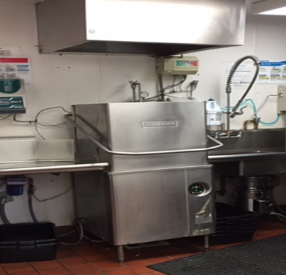
Type II hoods are meant to remove heat, moisture, and odors and are mainly used over non-grease producing equipment. They do not contain grease filters and are not designed for the collection and removal of smoke and/or grease. Type II hoods should not be installed over grease/smoke producing equipment.

Specific knowledge and expertise are needed for the proper installation of ventilation hoods systems. It is highly recommended that an operator works with a licensed ventilation expert. Licensed ventilation experts can properly size and install a ventilation hood system to ensure that it meets construction and design requirements and that it is of the correct type. They can also ensure that the system is sized properly to exhaust effluent and that an appropriate amount of makeup air is supplied. Licensed ventilation experts can run an air balance test which can be provided to the regulatory authority conducting the plan review. Having an improperly installed ventilation system can delay the approval and use of your STFU/mobile food establishment as well as create safety issues.
Type II hood over heat/moisture producing dishmachine

It is the responsibility of an STFU/mobile food establishment’s operator to check with each local jurisdiction (e.g. city, township, etc.) in which they will operate, to see if there are local requirements pertaining to mechanical ventilation and fire suppression for a STFU/mobile food establishment.

STFU and Mobile Food Establishment Worksheet Help
Worksheet  Question #10 |  | Food Code &  Food Law | Guidance
Item A | Ventilation | FC 4-202.18, 4-204.11, 4-301.14, 6-202.15(D), 6-304.11, 6-501.14 | - On the worksheet:  - Indicate if mechanical ventilation will be provided.  - If provided, indicate if proposed hood is Type I or Type II.  - If applicable, indicate how makeup air will be provided:  - Installation of makeup air unit; or  - Air pulled from protected openings in the STFU/mobile food establishment.
Item B | Equipment Underneath Hood |  | - If applicable, indicate on the worksheet what equipment will be located underneath the ventilation hood.
*FC =Michigan Modified Food Code. *FL = Food Law
To view the food code, food law and other fact sheets go to: http://www.michigan.gov/mdard/0,4610,7-125-50772_45851_61711---,00.html or call 800-292-3939 to request single free copies.

PART 11
Additional Circumstances

This section is used to address circumstances that are specific to the STFU/mobile food establishment and are not accounted for anywhere else in the submitted plan review documents. The regulatory authority may adjust procedures outlined in the Worksheet to comply with Food Code and Food Law. These adjustments may be added to Part 11 of the Worksheet.

PART 12
Diagram

A layout diagram of the STFU/mobile food establishment is needed to show the location of all your equipment (e.g. cooking, refrigeration, tabletops, water supply tanks, wastewater tank, water heaters, handsinks, etc.). This is needed to determine that sufficient equipment is proposed, spaced appropriately, and located to allow proper food safety practices. The layout diagram needs to be scaled and the scale utilized must be indicated (e.g. 1/4 inch = 1 foot). Photos, showing all parts of interior and exterior, of the STFU/mobile food establishment may be provided (depending upon your regulatory authority) instead of or in addition to a layout diagram. The dimensions of the unit in the photos should be provided along with dimensions of the equipment. 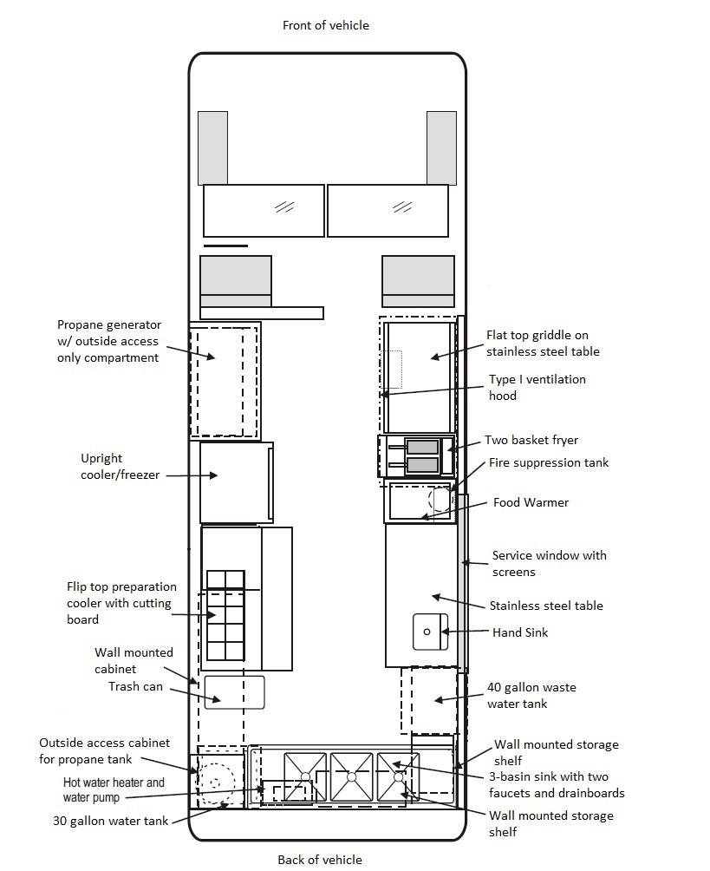
Sample Diagram

STFU and Mobile Food Establishment Worksheet Help
Worksheet  Question #12 |  | Food Code &  Food Law | Guidance
 | Diagram | FC 8-201.12(C) | - On the worksheet attach:  - A scaled layout diagram of STFU/mobile food establishment and indicate scale used; or  - Attach photos of the interior/exterior of STFU/mobile food establishment and equipment and include the dimensions of STFU/mobile food establishment and equipment.  - In some instances, the regulatory authority may need both a layout diagram and photos in order to conduct effective plan review.
*FC =Michigan Modified Food Code. *FL = Food Law
To view the food code, food law and other fact sheets go to: http://www.michigan.gov/mdard/0,4610,7-125-50772_45851_61711---,00.html or call 800-292-3939 to request single free copies.

Acknowledgements

This document was created utilizing information from Conference for Food Protection (CFP) 2014 “Recommended Guidance for Mobile Food Establishments” document and Ottawa Department of Public Health’s “STFU Plan Review Manual” document.

CFP 2014 “Recommended Guidance for Mobile Food Establishments” can be found at:
http://www.foodprotect.org/guides-documents/recommended-guidance-for-mobile-food-establishments/

Creation of MDARD Special Transitory Food Unit and Mobile Food Establishment
Plan Review Manual completed in 2018 by:

Local Public Health:
- Allegan County Health Department, Rebecca Long
- Health Department of Northwest Michigan, Brandon Morrill
- Kalamazoo County Health Department, Chris Kujawa
- Livingston County Health Department, Amy Aumock & Brad Zulewski
- Macomb County Health Department, Lucy Brown & G. Michelle Ingram
- Oakland County Health Department, Sara Burch & Josh Nelson
- Washtenaw County Health Department, Alan Hauck
- Wayne County Health Department, Terry Linna

Industry:
- Meijer, Scott Gilliam
- NSF International, Derek DeLand
- Patty Matters STFU, Lauren D' Angelo

Michigan Department of Agriculture and Rural Development:
- Amanda Garvin
- Shane Green
- Susan Trombley

